LAB TASK – 2

# Program-1:

#include<stdio.h>

int main(){

int arr[5],a;

printf("enter the number of elements: ");

scanf("%d",&a);

for(a=0;a<5;a++){

printf("elements %d:",a);

scanf("%d",&arr[a]);

}

printf("\n elements in an array are:");

for(a=0;a<5;a++){

printf("%d ",arr[a]);

}

printf("\n");

return 0; }

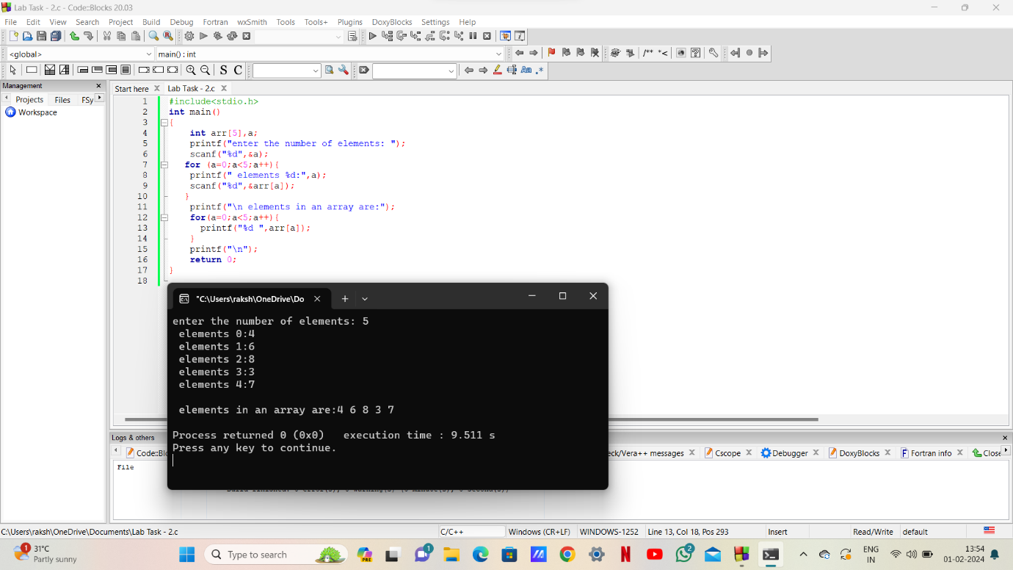

# Program-2:

#include<stdio.h>

int main(){

int arr[5],i,n;

printf("enter the number of elements in the array: ");

scanf("%d",&n);

for(i=0;i<n;i++){

printf("arr[%d]:",i);

scanf("%d",&arr[i]); }

printf("normal order:\n");

for(i=0;i<n;i++){

printf("%d ",arr[i]); }

printf("\n");

printf("the reverse order:\n");

for(i=n-1;i>=0;i--){

printf("%d",arr[i]);}

return 0;

}

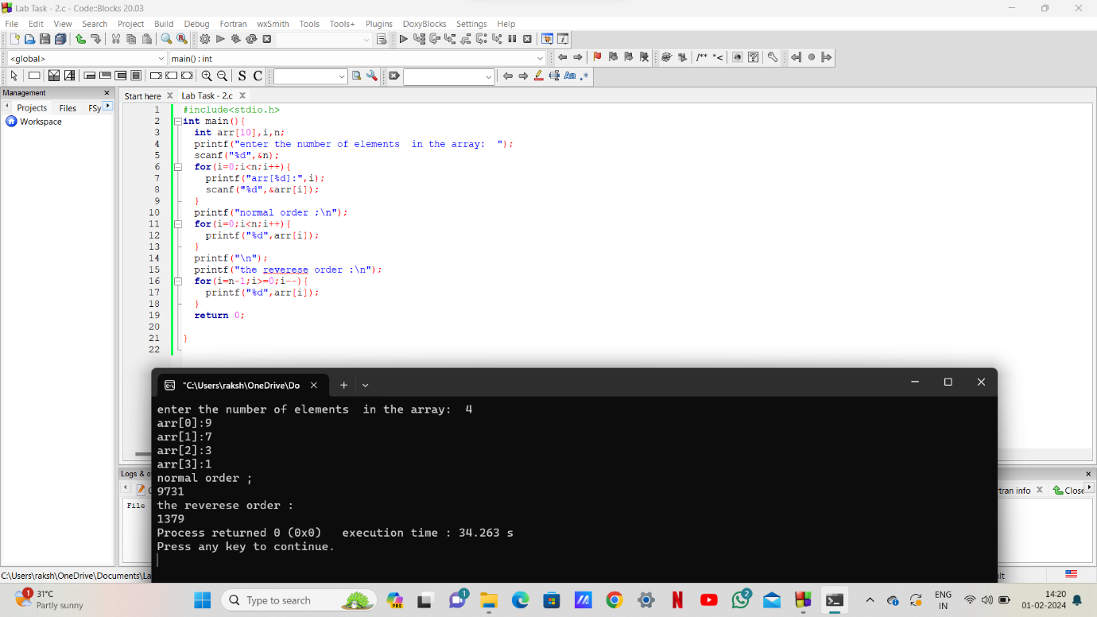

# Program-3:

#include<stdio.h>

int main(){

int arr[50],size,i,sum=0;

printf("enter the size of array: ");

scanf("%d",&size);

printf("enter the elements of array: ");

for(i=0;i<size;i++){

scanf("%d",&arr[i]);

}

for(i=0;i<size;i++)

sum = sum + arr[i];

printf("sum of the elements of the array = %d\n",sum);

return 0;

}

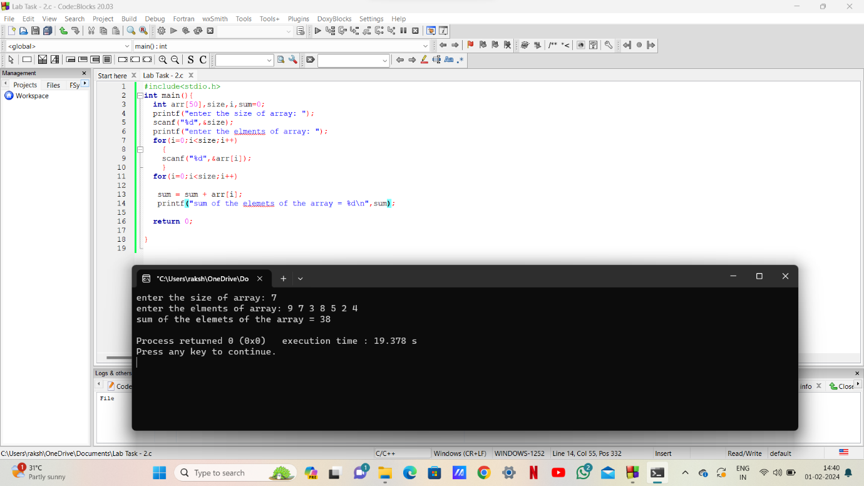

# Program -4:

#include<stdio.h>

int main(){

int arr[50],size,i,j,count=0;

printf("enter the size of array: ");

scanf("%d",&size);

printf("enter the elments of array: ");

for(i=0;i<size;i++) {

scanf("%d",&arr[i]);}

for(i=0;i<size;i++){

for(j= i+1;j<size;j++){

if(arr[i] == arr[j]){

count++;

break; }

}

}

printf("total number of duplicate elements in the array =%d",count);

return 0;

}

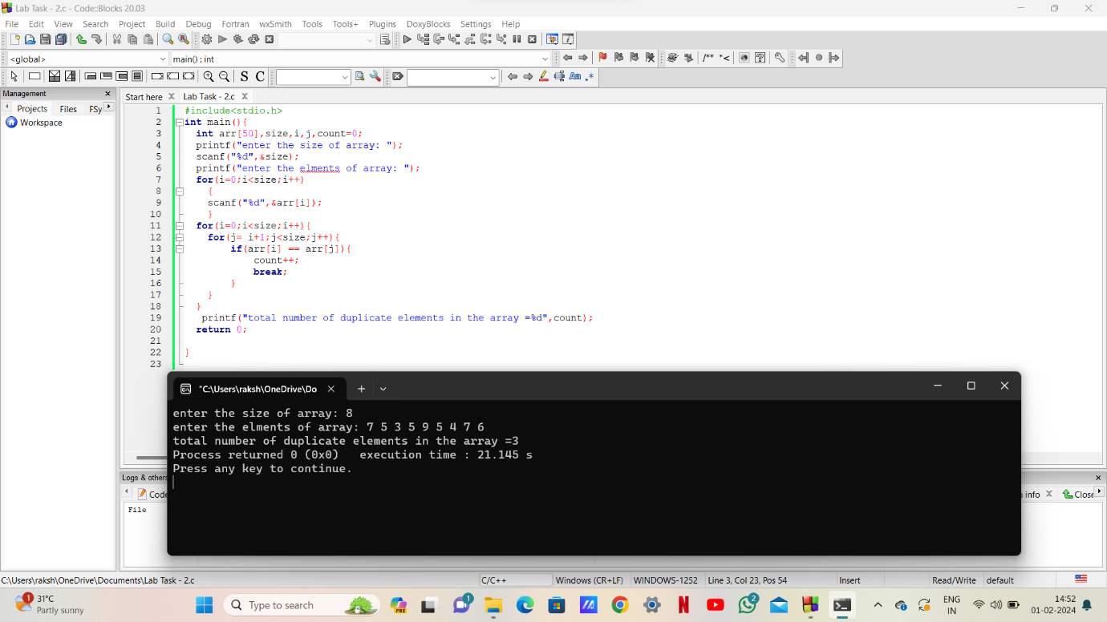

# Program-5:

#include <stdio.h>

int main() {

int n,arr[50],i,j;

printf("Enter the array size: ");

scanf("%d",&n);

printf("Enter the elements:\n", n);

for (i = 0;i<n;i++) {

scanf("%d",&arr[i]);

}

printf("Unique elements in the array:\n");

for (i=0;i<n;i++) {

for (j=0;j<i;j++) {

if (arr[i] == arr[j]) {

break;}

}

if (i == j) {

printf("%d ", arr[i]); }

}

return 0;}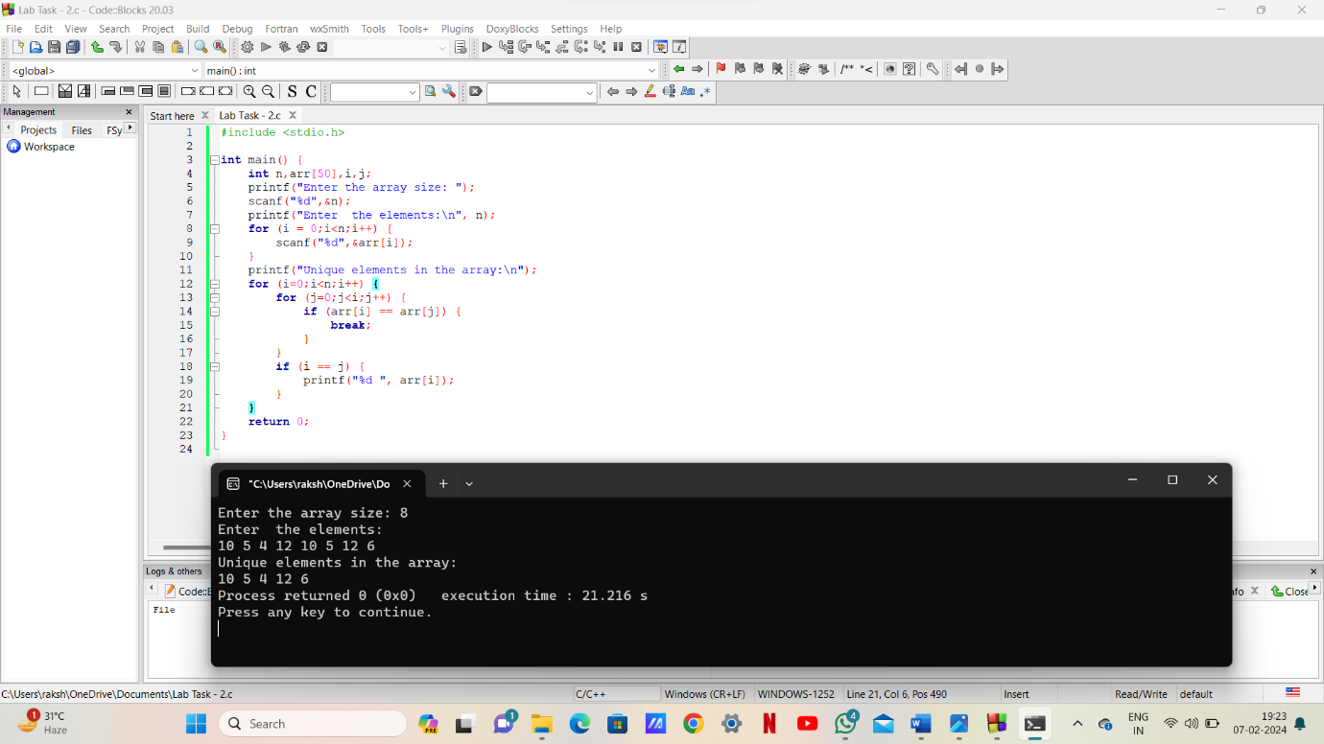

# Program-6:

#include<stdio.h>

int main(){

int a[50],i,n,num,p;

printf("enter the size of array:");

scanf("%d",&n);

printf("enter the elements of array:");

for(i=0;i<n;i++) {

scanf("%d",&a[i]);}

printf("enter the numbers to insert:");

scanf("%d",&num);

printf("enter the position :");

scanf("%d",&p);

for(i=n-1;i>=p-1;i--){

a[i+1]=a[i];}

a[p-1]=num;

n++;

for(i=0;i<n;i++){

printf("%d",a[i]);}

return 0;}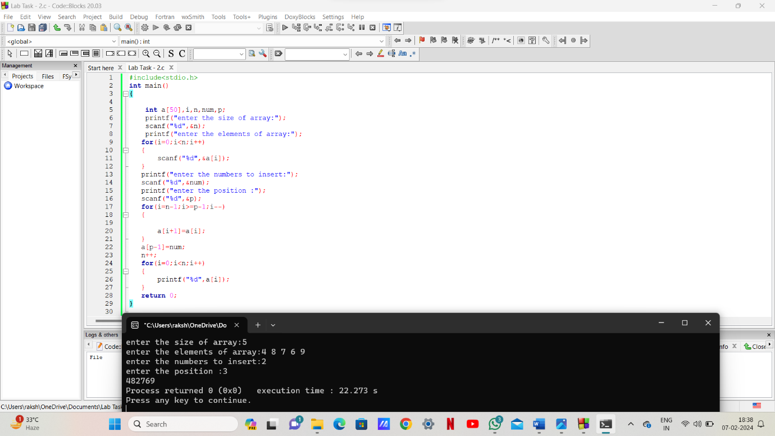

# Program-7:

#include<stdio.h>

int main(){

int a[50],i,n,p;

printf("enter the size of array:");

scanf("%d",&n);

printf("enter the elements of array:");

for(i=0;i<n;i++){

scanf("%d",&a[i]);}

printf("enter the position for deleting element:");

scanf("%d",&p);

for(i=p-1;i<n;i++){

a[i]=a[i+1];}

n--;

for(i=0;i<n;i++){

printf("%d",a[i]);}

return 0;}

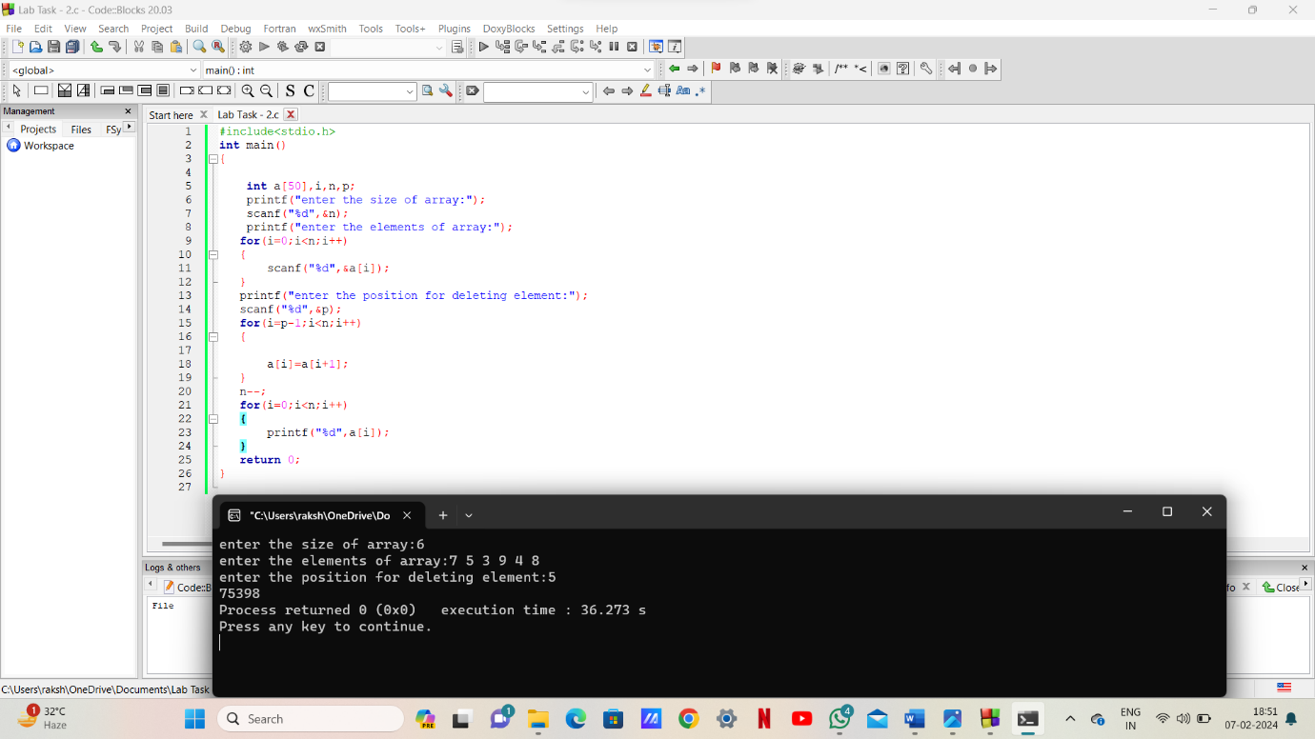

***THE END***